Problem areas and improvements
The biggest hurdle / problem I encountered when writing this script was that if the domain detected the web driver , you were automatically locked out from progressing through the rest of the script .

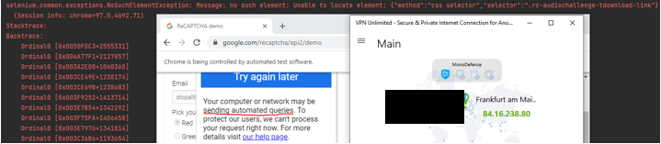
Figure 1 – Bot being detected

After a few consecutive runs of the page , my activity became suspicious – and the reCAPTCHA was nulled ; so, the script stopped as the element it was looking for was not in the current frame. The work around to this was for me to use incognito mode , make sure no cookies were stored and switching location on VPN/proxy after every few attempts .

I tried numerous methods to try and resolve this including, flush dns , reset winsock , and adding many options to the chrome driver ( in set up function) that from research of numerous sources , improve un-detectability of the web driver. Along with adding the option to run Chrome in headless mode which runs the browser without and display or GUI (Beckerman,2018).These options greatly improve un-detectability , but are not bullet proof , and still left me having to change VPN server after several consecutive runs. Due to this , I added some code that if the error message of bot detected was found , the script would terminate as no other element was searchable.

I discovered selenium’s proxy module, which I tinkered with grabbing free proxy servers from https://free-proxy-list.net/ with special soup and panda and storing them in a list to parse to the proxy module. However , this was completely unreliable as the servers are first come first serve and would often not find a single server which I could get a connection from. However , this is an area that could be a huge improvement and could be implemented to switch proxy if driver is discovered and automatically restart script, which in itself – is another exercise completely.

Future improvements List
- Find a way to implement proxy module with a reliable list of proxy servers
- Automate switching proxy if driver is detected
- Improve convenience by making the script auto detect path to chromedriver.exe

